Queer Brooklyn based duo, Tropic, release disco tinged Electro-R&B track ‘So Good’ Friday, September 17th, 2021 (Listening link below)

“Built on dreamy synths, lush melodies, and heartwarming vocals provided by frontman Jo-B Sebastian, ‘Bittersweet’ delivers a mix of the old and the new.” - Earmilk

“‘Breathe Again’ is also said to be the first taste of an EP these boys are working on together, and if there’s going to be more of this on there, I’m in.” - Acid Stag

“Tropic is our latest obsession and they should be yours too.” - AudibleAddixion

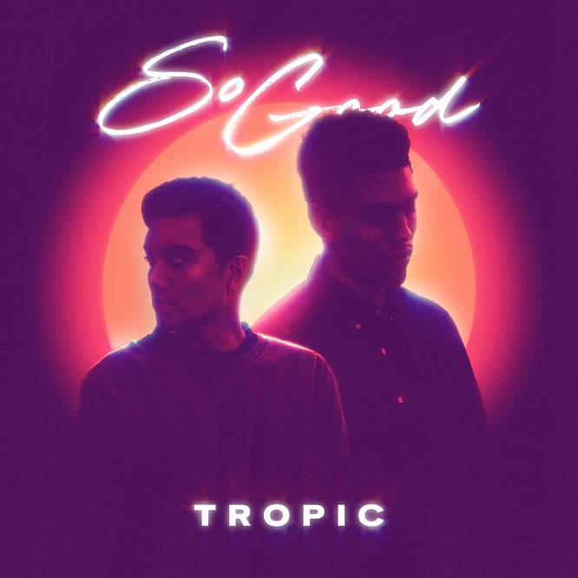
Set over lush chords, sparkling guitars, and an inescapable bassline, Tropic’s latest single ‘So Good’ is the Brooklyn-based duo’s feel good send off to summer. Drawing musical inspiration from the shimmery, hedonistic euphoria of the disco era, the new single is a light hearted reminder to let loose and enjoy life.

“We wanted to end the summer with a bang and our new track ‘So Good’ felt like the perfect fit. Infused with nostalgia and feel-good optimism, we wanted to throw it back with this disco-tinged track, something you could listen to while getting ready for a night out, something you could fall in love to, something that would be equally at home on a smokey dancefloor or poolside, cocktail in hand. With so much uncertainty looming over our heads this past year we all need something to feel good about, and a dance party, even for one, might be just the thing.”

Fast becoming an unstoppable force in 2021, Tropic’s signature sound has captured the attention of critics and fans alike. Their recent single ‘Alive’ received immense support from Spotify’s editorial team, garnering placements on 9 New Music Friday playlists across Asia. Constantly on rotation on 3 Spotify editorial playlists, the single is swiftly approaching a million streams and their subsequent releases are regularly featured on Spotify’s New Music Friday and other editorial playlists. Their recent single ‘Control’ was featured on Pat Lok’s House of Jade mix for 88Rising. Alongside names like Tokimonsta & Robotaki, the mix highlights the best of Asia’s up and comers.

‘So Good’ is out September 17th on all major music outlets.

Soundcloud Promo Link - https://soundcloud.com/tropicclouds/control/s-Gf0tELKHqSd

Tropic is available for press opportunities. Please email: contact@tropicofficial.com

About Tropic

New York based duo Tropic is what happens when electronic producer & DJ, Phuse, and R&B singer/songwriter Jo-B Sebastian join forces. Born from a mutual respect for each other’s inspirations and musical work, Tropic blends R&B textures, electronic landscapes, pop hooks, and funk rhythms, combining Phuse’s slick, luscious production and beats, with Jo-B’s velvety vocals, heartfelt lyrics, and catchy melodies.

Equal parts nostalgic throwback and futuristic daydreaming, Tropic is fast becoming an unstoppable force in 2021. Their signature sound has captured the attention of critics and fans alike. Their recent single 'Alive' was added to Spotify's New Music Friday editorial playlists in 9 countries and is currently on constant rotation on 3 Spotify editorial playlists, amassing more than 1,000,000 streams since its release. Their single, a heartfelt tribute to the Mariah classic 'Always Be My Baby', was put on Spotify's New Music Friday Philippines playlist and was also added to Spotify's Pride-centric playlist 'Bahaghari'. Their following single, 'Secret' was added to Spotify's New Music Friday and has racked up more than 100,000 streams since its release in July.

With praise from publications like Earmilk and Acidstag, upcoming tour dates, and much more music on the horizon the duo shows no sign of slowing down.

Links

Official Website
Electronic Press Kit
Spotify
Instagram
Twitter

