Brooklyn based duo, Tropic, release an exciting funk-infused track entitled, ‘Paradise on Friday, September 25th, 2020 (Listening link below)

“Built on dreamy synths, lush melodies, and heartwarming vocals provided by frontman Jo-B Sebastian, ‘Bittersweet’ delivers a mix of the old and the new.” - Earmilk

“‘Breathe Again’ is also said to be the first taste of an EP these boys are working on together, and if there’s going to be more of this on there, I’m in.” - Acid Stag

“Tropic is our latest obsession and they should be yours too.” - AudibleAddixion

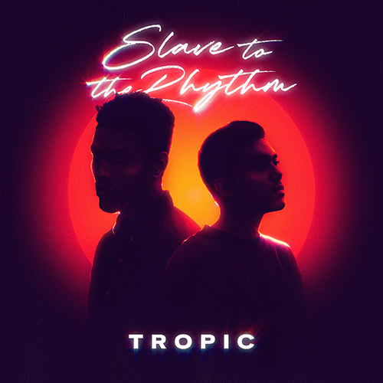
Fresh off a whirlwind 2020, Brooklyn based Electro-R&B duo Tropic are back with their first release of the new 2021. Their new single ‘Slave to the Rhythm’ is an 80s funk inspired dance track that harks back to the memories of packed dance floors and nights out on the town. Dejected and frustrated at the current state of things, and having been forced to cancel tours and upcoming shows, Tropic’s new single hopes to serve as a reminder that better days are coming.

Equal parts nostalgic throwback and futuristic forward thinking, Tropic is fast becoming an unstoppable force in 2020. Their signature sound has captured the attention of critics and fans alike. Tropic’s recent single ‘Alive’ received immense support from Spotify’s editorial team, garnering placements on 9 New Music Friday playlists across Asia. The single has since been on constant rotation on 3 Spotify editorial playlists and has racked up more than 700,000 streams since its release. The single's remix was also added to Spotify's Electro Mix playlist.

“Born from a place of frustration and anxiety for the uncertain future ahead of us, our new single ‘Slave to the Rhythm’ is a reminder that sometimes, we have to take a moment to let loose and let go. We’ve seen and felt the effects of the pandemic, how it has become an ever present topic in any conversation, crushed our spirits, and dampened our outlook on life. We wanted to help people remember that joy can be found in the smallest of things, and that sometimes surrendering to the things we cannot control can help us find a way to enjoy life again. Music has always been our anchor, a constant in our life that can never be taken away from us, and hopefully it can be a way to see us through these dark times.”

‘Slave to the Rhythm’ is out Friday, March 5th on all major music outlets.

Soundcloud Promo Link - https://soundcloud.com/tropicclouds/slave2therhythm/s-iZc7FIfqSP8

Tropic is available for press opportunities. Please email: contact@tropicofficial.com

About Tropic

New York based duo Tropic is what happens when electronic producer & DJ, Phuse, and R&B singer/songwriter Jo-B Sebastian join forces. Born from a mutual respect for each other’s inspirations and musical work, Tropic blends R&B textures, electronic landscapes, pop hooks, and funk rhythms, combining Phuse’s slick, luscious production and beats, with Jo-B’s velvety vocals, heartfelt lyrics, and catchy melodies.

Equal parts nostalgic throwback and futuristic daydreaming, Tropic is fast becoming an unstoppable force in 2021. Their signature sound has captured the attention of critics and fans alike. Their recent single 'Alive' was added to Spotify's New Music Friday editorial playlists in 9 countries and is currently on constant rotation on 3 Spotify editorial playlists, amassing more than 700,000 streams since its release. Their single, a heartfelt tribute to the Mariah classic 'Always Be My Baby', was put on Spotify's New Music Friday Philippines playlist and was also added to Spotify's Pride-centric playlist 'Bahaghari'. Their following single, 'Secret' was added to Spotify's New Music Friday and has racked up more than 100,000 streams since its release in July.

With praise from publications like Earmilk and Acidstag, upcoming tour dates, and much more music on the horizon the duo shows no sign of slowing down.

Links

Official Website
Electronic Press Kit
Spotify
Instagram
Twitter

