Brooklyn-based Electro-R&B duo Tropic sizzles with new summer single ‘Missing U’ out Friday, August 25th. (Listening link below)

“Built on dreamy synths, lush melodies, and heartwarming vocals provided by frontman Jo-B Sebastian, ‘Bittersweet’ delivers a mix of the old and the new.” - Earmilk

“‘Breathe Again’ is also said to be the first taste of an EP these boys are working on together, and if there’s going to be more of this on there, I’m in.” - Acid Stag

“Tropic is our latest obsession and they should be yours too.” - AudibleAddixion

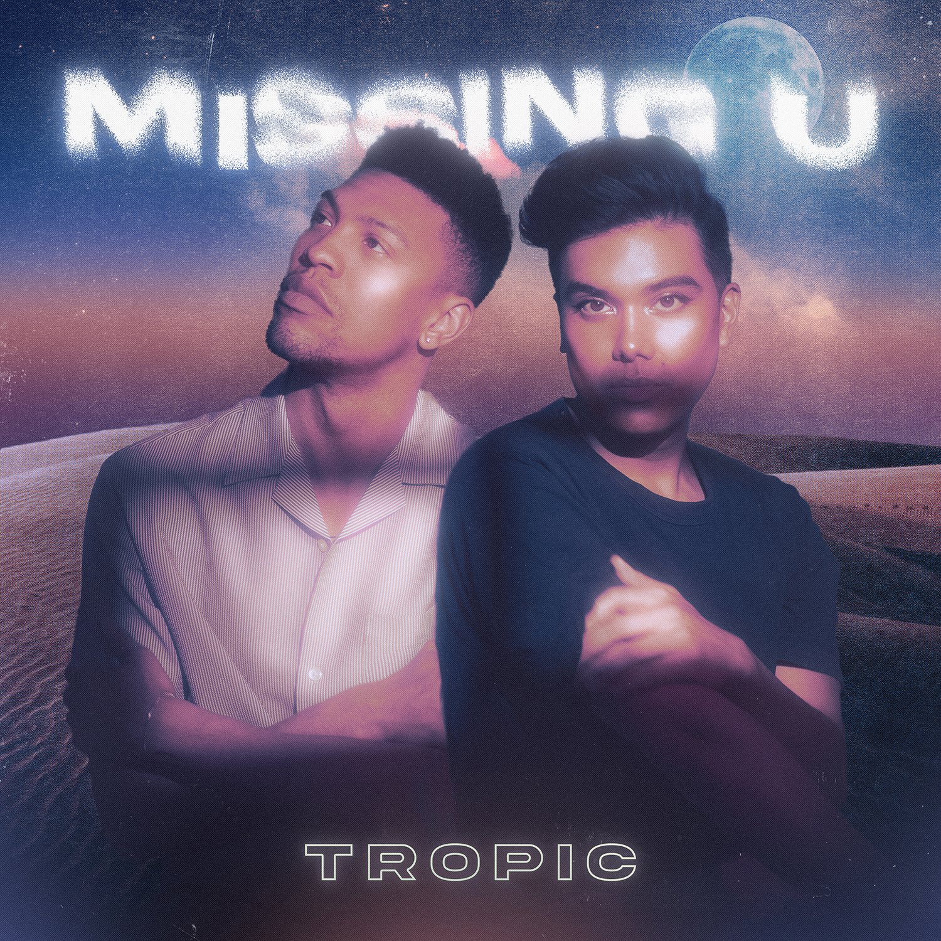

Hot off the heels of their single ‘Boy’, Electro-R&B duo Tropic is back with their song of the summer ‘Missing U’. Amidst a canopy of tropical rhythms, sparkling harmonies, and sunkissed chords, ‘Missing U’ celebrates the joy of finally ending a toxic relationship and the empowerment of moving on and finally seeing your self-worth. The feel-good, laidback kiss-off track is the second single off their upcoming EP, which promises to be an exploration & celebration of the queer experience.

“Whether it's romantic, platonic, familial, or professional, most of us have had the misfortune of experiencing a toxic relationship. With ‘Missing U’ we wanted to put a twist on the typical breakup song. Instead, we highlighted the joy and liberation that comes with finally closing the door on someone who just isn’t good for you. Sometimes the only way to grow is to let go and we hope this song can be an anthem for anyone who has found the strength to leave or who needs a push in the right direction.”

‘Missing U’ is out on Friday, August 25th on all major music platforms.

Soundcloud Promo Link - https://on.soundcloud.com/hEVdz

Tropic is available for press opportunities. Please email: contact@tropicofficial.com

About Tropic

Brooklyn-based duo Tropic is what happens when West Coast electronic producer & DJ, Phuse, and Queer, Filipino R&B singer/songwriter Jo-B Sebastian join forces. Born from a mutual respect for each other’s inspirations and musical work, Tropic blends R&B textures, electronic landscapes, pop hooks, and funk rhythms, combining Phuse’s slick, luscious production and beats, with Jo-B’s velvety vocals, heartfelt lyrics, and catchy melodies.

Equal parts nostalgic throwback and futuristic daydreaming, Tropic is fast becoming an unstoppable force in 2023. Their signature sound has captured the attention of critics and fans alike. Their lead single ‘Wildest Dreams’ from their latest EP was added to Spotify's New Music Friday editorial playlists in 10 countries while their song ‘Alive’, also taken from the same EP, is on constant rotation on 3 Spotify editorial playlists. The ‘Wildest Dreams’ has amassed more than 2 million streams and counting since its release. Their recent single, Control, was selected by Kitsuné’s Pat Lok for his House of Jade mix for 88Rising. Placing Tropic amongst artists like Tokimonsta & Robotaki, the mix highlights the best of Asia’s up-and-comers. At the close of 2021 the Philippines’ biggest music channel, MYX, invited Tropic to perform for their MYX TRAKS Live performance series, introducing Tropic to the channel’s 1.4 million subscribers.

With praise from publications like Earmilk and Acidstag, an upcoming EP, tour dates, and much more music on the horizon the duo shows no sign of slowing down.

Links

Official Website
Electronic Press Kit
Spotify
Instagram
Twitter

