Brooklyn based Electro-R&B duo Tropic release funky reimagining of Mariah Carey classic ‘Always Be My Baby’ on Friday, June 5, 2020 (Listening link below)

“Built on dreamy synths, lush melodies, and heartwarming vocals provided by frontman Jo-B Sebastian, ‘Bittersweet’ delivers a mix of the old and the new.” - Earmilk

“‘Breathe Again’ is also said to be the first taste of an EP these boys are working on together, and if there’s going to be more of this on there, I’m in.” - Acid Stag

“Tropic is our latest obsession and they should be yours too.” - AudibleAddixion

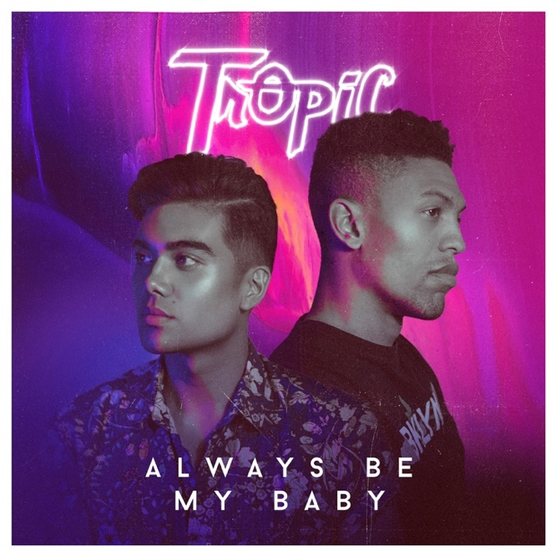
Brooklyn based Electro-R&B duo Tropic returns with a funk-driven tribute to the legendary Mariah Carey, playfully reimagining her eternal classic ‘Always Be My Baby’. Built around powerhouse vocals, Tropic’s blend of smooth electronic sensibilities and soulful grooves creates an interpretation that is an exuberant homage to the source material yet is irreverently distinct.

“As a queer singer and songwriter, Mariah Carey is the bar that I aspire to in all my musical endeavors. Her glittering story is an inspiration to so many. We wanted to celebrate her 30th anniversary in the industry, paying homage to a woman who has blazed such an important trail. ‘Always Be My Baby’ has cemented itself as a perennial summer jam and is one of those infectious, feel-good songs that no one can resist singing along to. In this time of hardship, we hope this sincere love letter helps usher in the summer and remind us of the better days to come.”

Always Be My Baby is out Friday, June 5th on all major music outlets.

Soundcloud Promo Link - https://soundcloud.com/tropicclouds/always-be-my-baby/s-HyBUV1Uccel

About Tropic

New York based duo Tropic is what happens when electronic producer & DJ, Phuse, and R&B singer/songwriter Jo-B Sebastian join forces. Born from a mutual respect for each other’s inspirations and musical work, Tropic blends R&B textures, electronic landscapes, pop hooks, and funk rhythms, combining Phuse’s slick, luscious production and beats, with Jo-B’s velvety vocals, heartfelt lyrics, and catchy melodies.

Equal parts nostalgic throwback and futuristic daydreaming, Tropic is fast becoming an unstoppable force in 2020. Their signature sound has captured the attention of critics and fans alike. Their recent single Alive was added to Spotify's New Music Friday editorial playlists in 9 countries and is currently on constant rotation on 3 Spotify editorial playlists, amassing more than 250,000 streams since its release. With praise from publications like Earmilk and Acidstag, upcoming tour dates, and much more music on the horizon the duo shows no sign of slowing down.

Links

Official Website
Electronic Press Kit
Spotify
Instagram
Twitter

